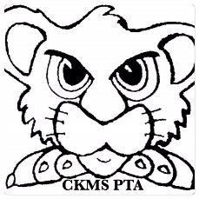
CKMS PTA CARES Program
The CKMS PTA Cares Program is in place to assist students who are not able to afford school supplies and related educational needs. CKMS Cares wants to ensure that all students have access to the supplies they need to succeed in school. Please consider a cash donation to purchase items such as graphing calculators, alarm clocks, USB flash drives, other class supplies and to pay class supply fees for students who could not otherwise afford them.
To help, please return this form with your check payable to “CKMS PTA” You may mail your contribution to- CKMS Cares, c/o CKMS PTA, Central Kitsap Middle School, PO Box 8, Silverdale, WA 98383-0008 OR Put it in the donation box at MAZE DAY.
Requests for supplies may be made through the counselor at CKMS. All requests are confidential and students remain anonymous to the PTA Board.
The program is included in the annual PTA budget and the PTA Executive Board manages funds. The Executive Board must approve individual requests exceeding $20 in value. ********************************
Please provide us with your name and address so we may send you a receipt for your tax- deductible donation. Name_____________________________ Address___________________________ __________________________________
I would like to donate: $5.00 $10.00 $15.00 $20.00 $_______

Thank you for your support of the CKJH CARES Program!

